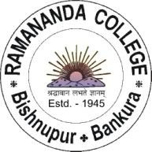
BISHNUPUR * BANKURA
Pin – 722122, West Bengal
UGC Recognized & State Government Aided Constituent College
Under Bankura University
Tel - 6297976619
Tele Fax – (03244) 254427
e-mail–principal@ramanandacollege.org Website-www.ramanandacollege.org

Ref. No. (Accredited by NAAC at ‘B++’ Level) Date- 01-11-2023

Notice

Department of Higher Education, Government of West Bengal, and CII are organizing an Education Symposium on 4th November 2023 from 10.00 a.m. with the theme "Higher Education & Realization of Sustainable Development: Paving the Way Forward". The entire program will be streamed live on the Higher Education Department's YouTube channel (https://www.youtube.com/@BanglarUchchashiksha) and Facebook (https://www.facebook.com/142340622291427).
For details of the Program, please visit: https://cam.mycii.in/OR/EventDetailOR.html?id=E000063814. Teachers and students of all departments of Ramananda College are requested to participate in this live event.

Cooperation is solicited.

Principal
Ramananda College

